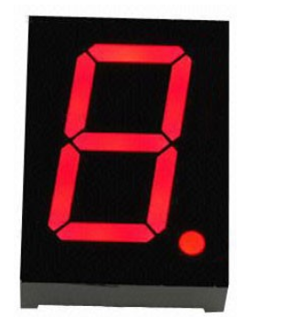7 segment display using RASPBERRY PI 3

Aditi Vaidya

vaidya19598@mail.npu.edu



Northwestern Polytechnic University Fremont, CA Copyright © 2017, All Rights Reserved .

Table of Contents

|  |  |  |  |
| --- | --- | --- | --- |
| 1.0 | Introduction | |  |
|  | 1.1 | Objective |  |
|  | 1.2 | Requirement |  |
|  | 1.3 | Principle |  |
| 2.0 | Hardware connections | |  |
| 3.0 | Working | |  |
|  | 3.1 | Programming |  |
|  |  | |  |

## Objective

The main objective is to built the circuit for driving a 7 segment display with Python programming using the Raspberry Pi 3 model B development board with inbuilt thony ide.

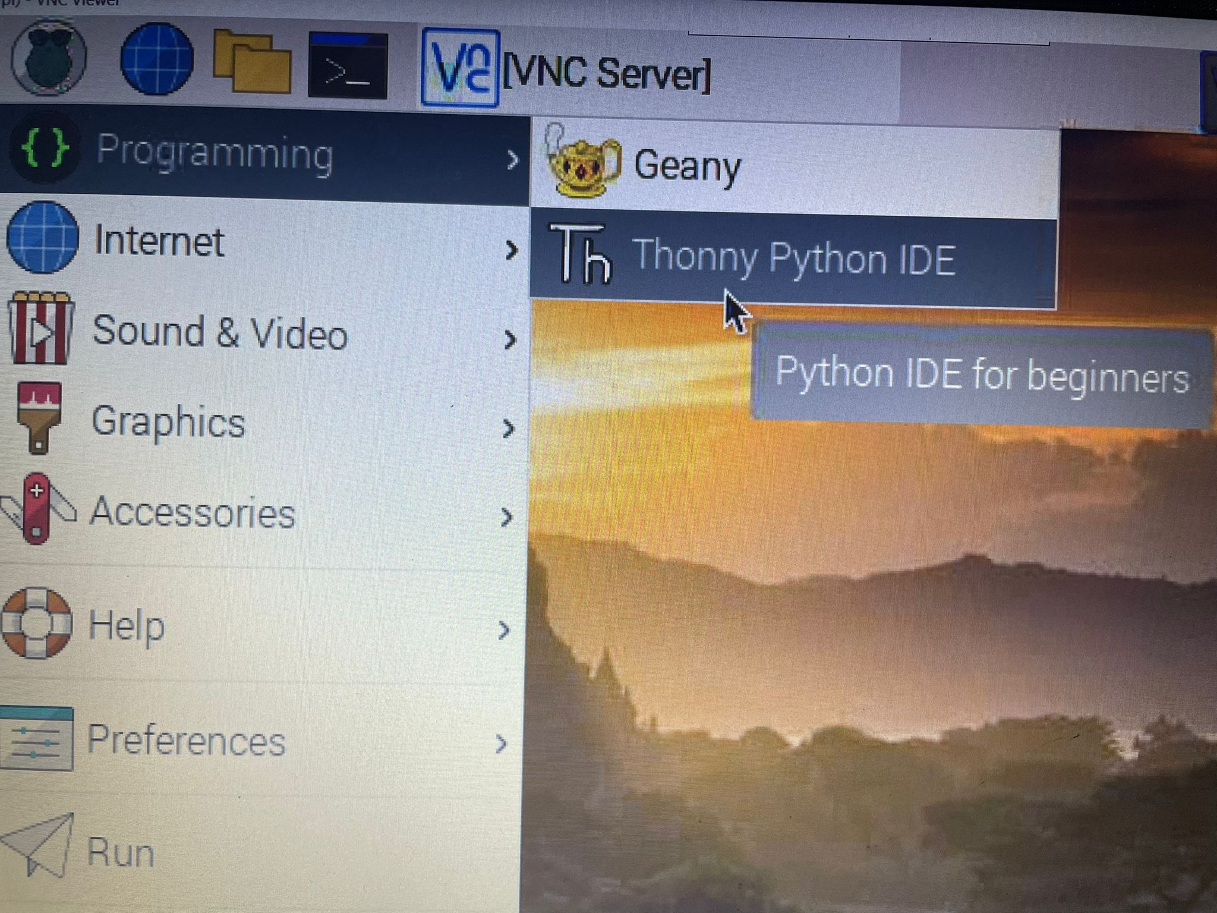

## Requirement

* 1 * Raspberry Pi
* 1 * Breadboard
* 1 * 74HC595
* 1 * 7-segment display
* 1 * Resistor (220Ω)
* Jumper wires

## Principle

 In this experiment ,initially the seven segment display is grounded. When Raspberry Pi output is supplied 7 segment with high (3.3V) by programming, those segments will light up but when low level is supplied to the IO of seven segment , the certain segment will be cut off and will stay dim.

## 2.0 Hardware connections

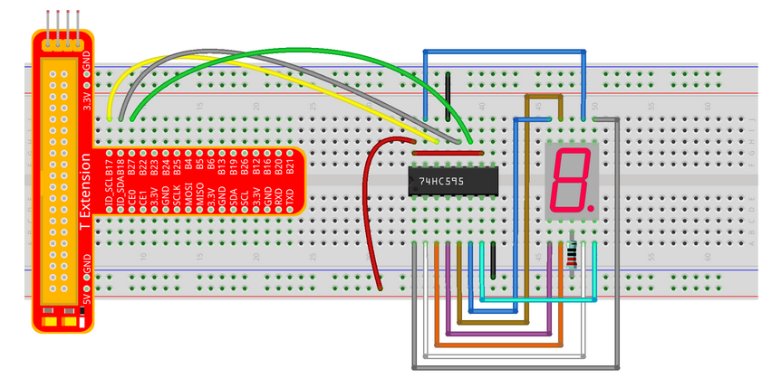Use the bread board and make connections as shown in visual representation below :

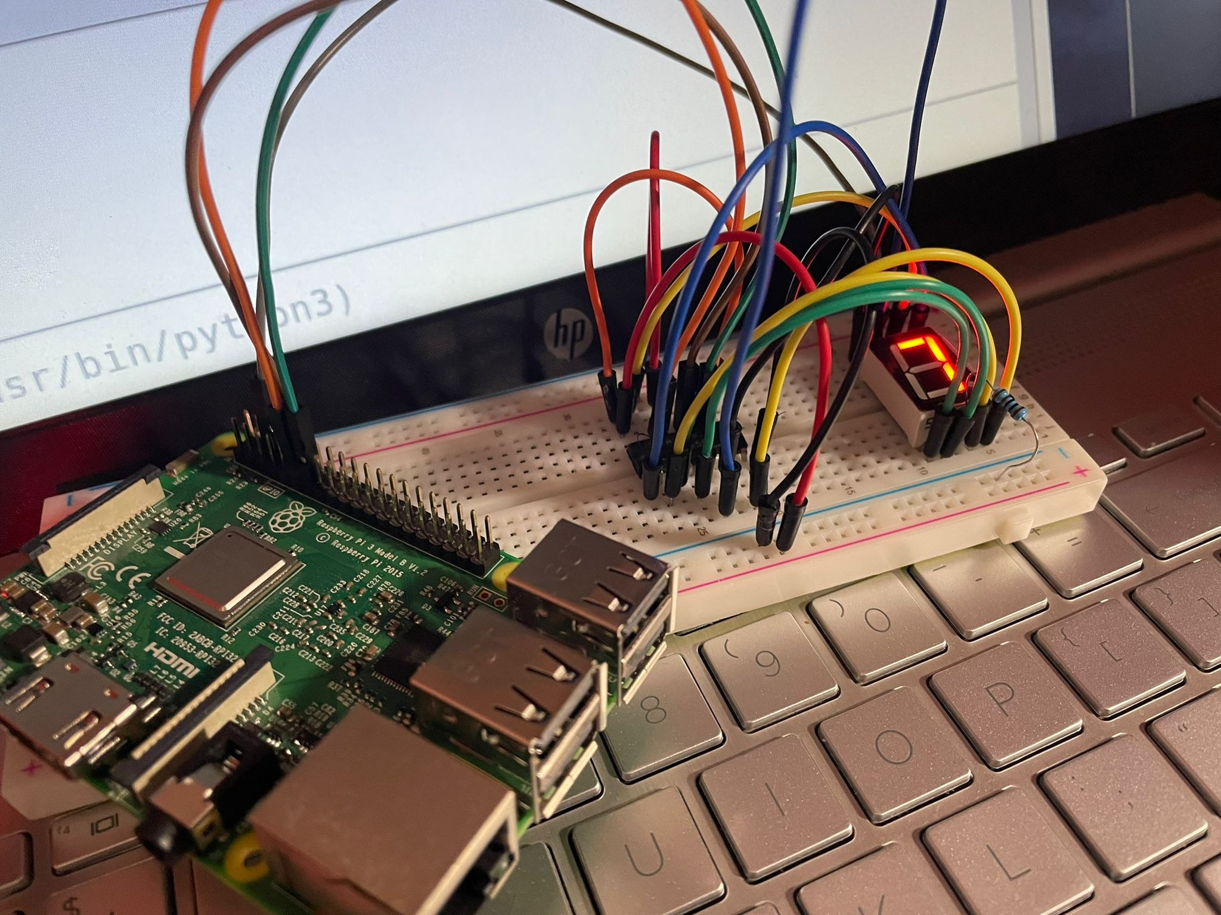

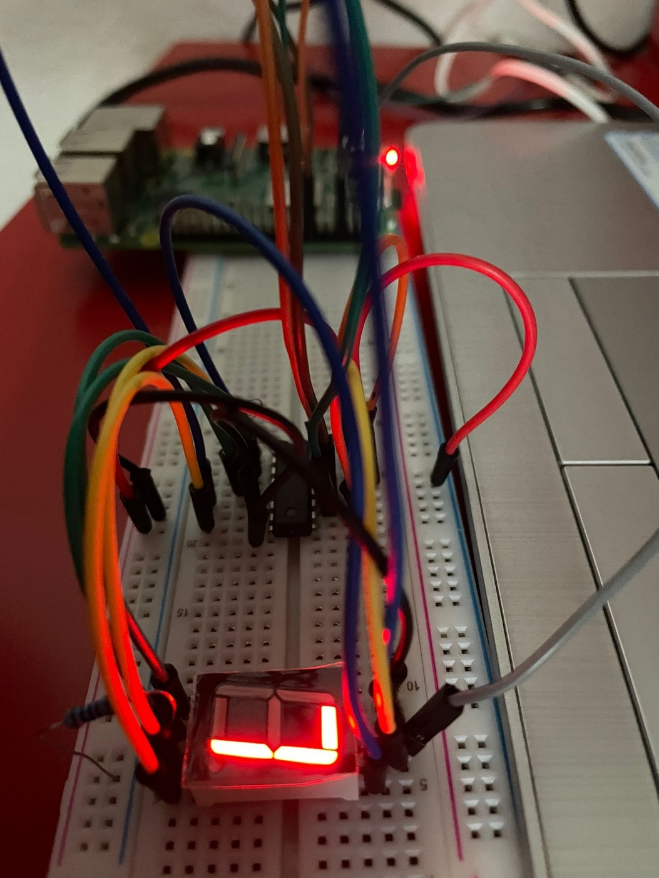

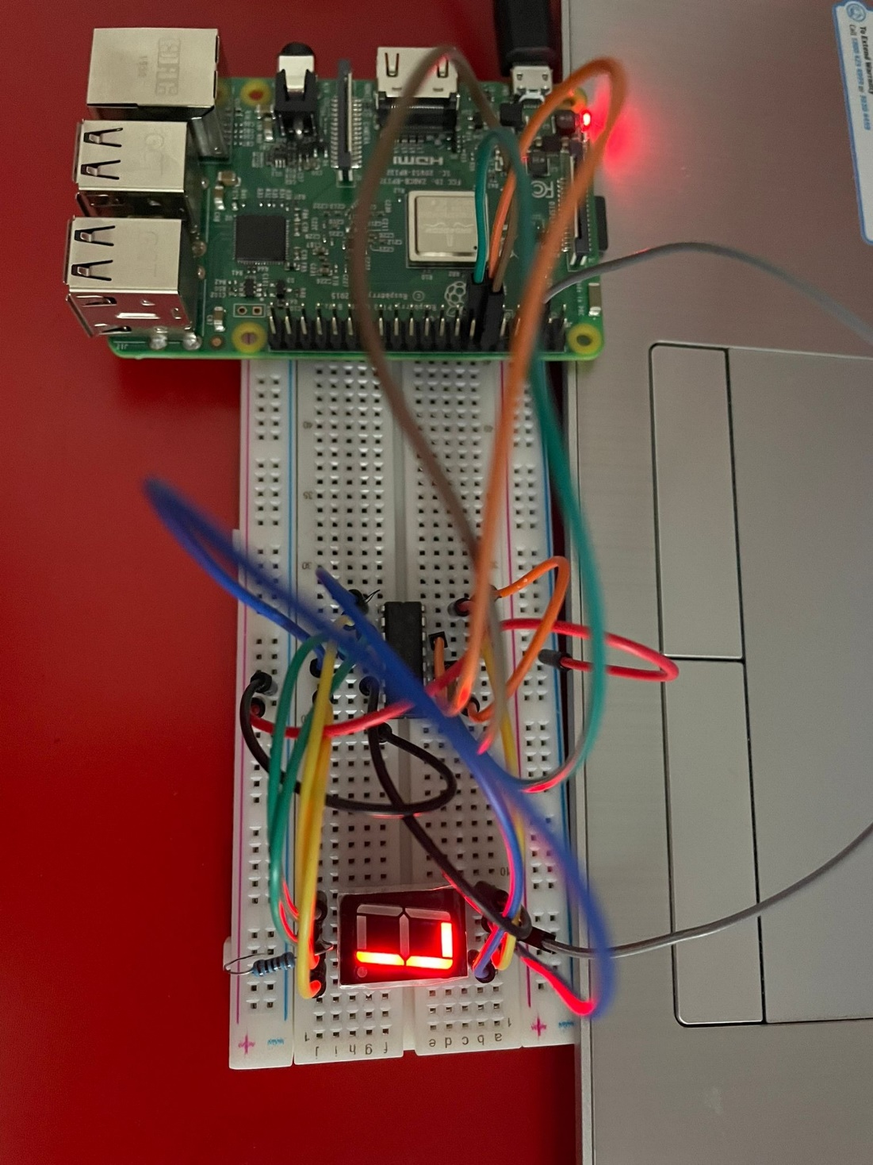

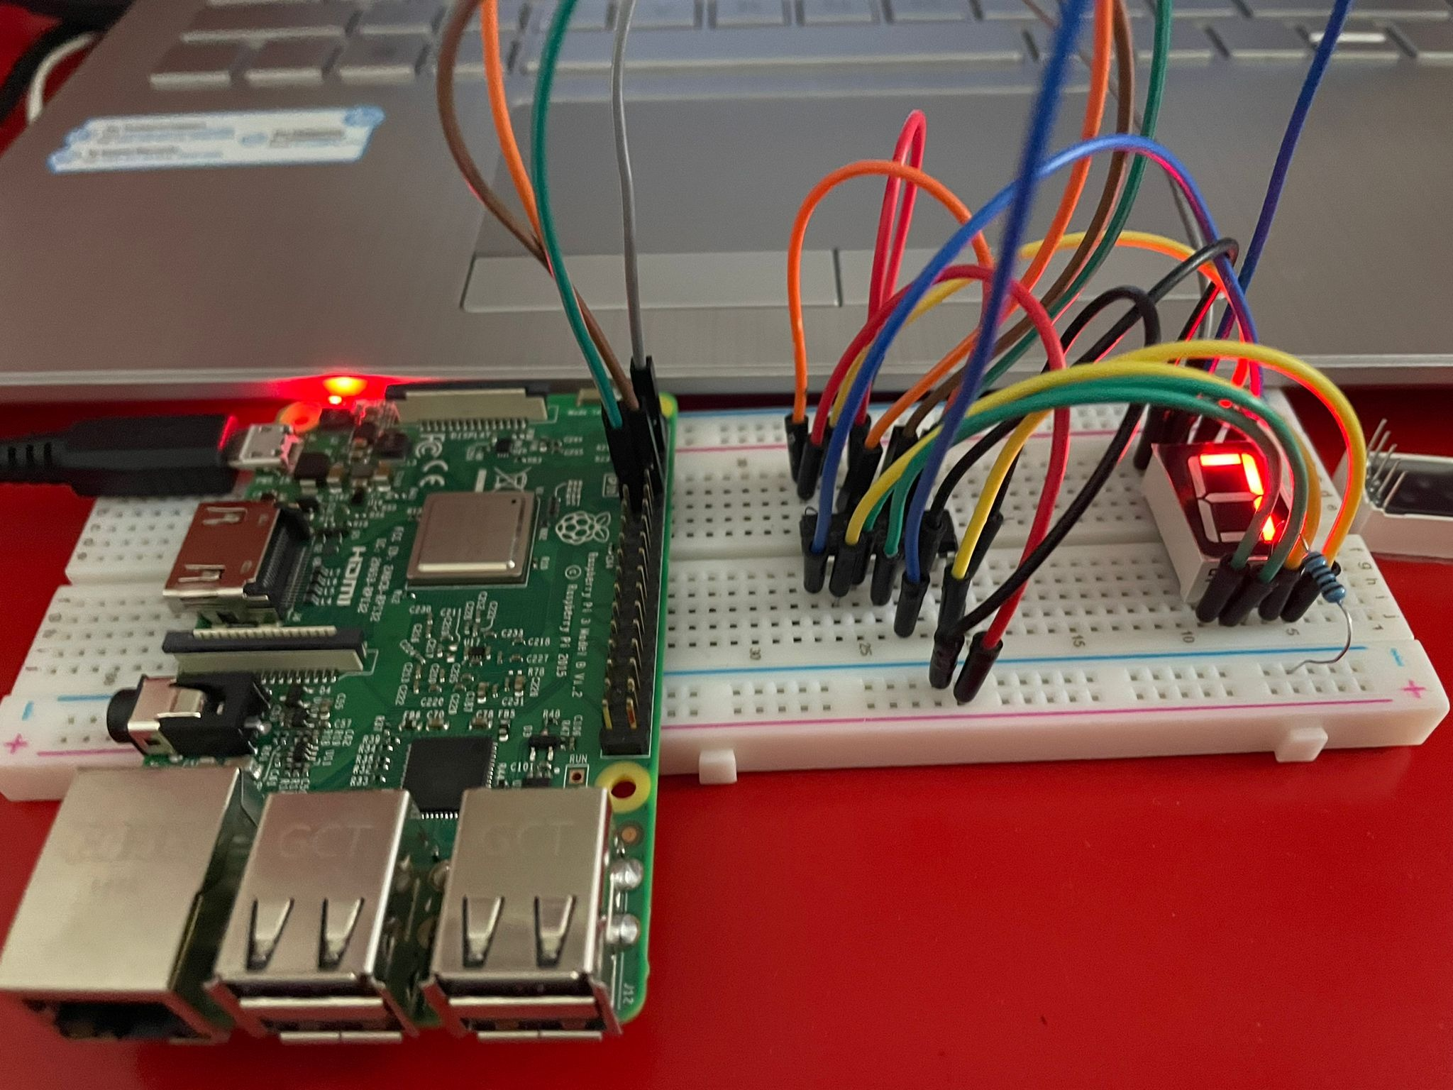

## Working

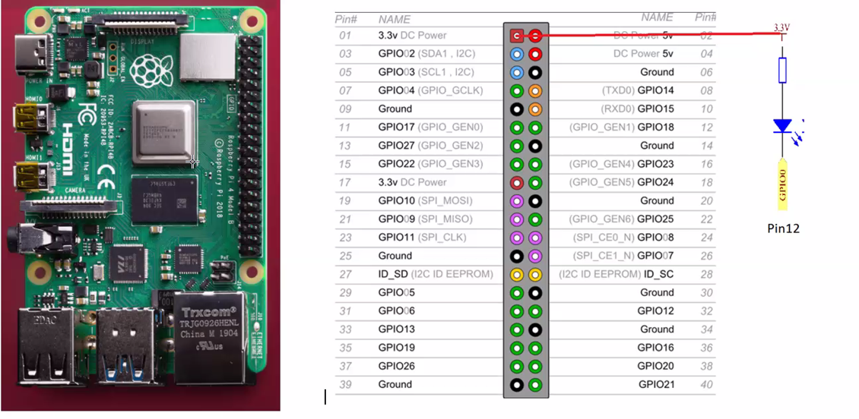Once the wireless connection is established then open thonny Python IDE which mostly is pre installed in raspberry Pi’s.

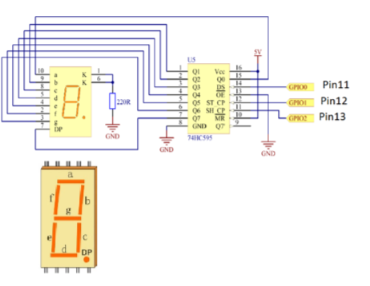

1. Make sure the Python library is uploaded and running .
2. Type in the program, and check for any errors.
3. Run the program
4. Check for buzzer .

|  |  |
| --- | --- |
| **3.1** | **Programming**  Enter the following program on Thonny Python IDE : |

#!/usr/bin/env python

import RPi.GPIO as GPIO

import time

# Set up pins

SDI = 17

RCLK = 18

SRCLK = 27

# Define a segment code from 0 to F in Hexadecimal

# Commen cathode

segCode = [0x3f,0x06,0x5b,0x4f,0x66,0x6d,0x7d,0x07,0x7f,0x6f,0x77,0x7c,0x39,0x5e,0x79,0x71]

# Commen anode

# segCode = [0xc0,0xf9,0xa4,0xb0,0x99,0x92,0x82,0xf8,0x80,0x90,0x88,0x83,0xc6,0xa1,0x86,0x8e]

def print_msg():

print ("========================================")

print ("| Segment with 74HC595 |")

print ("| ------------------------------ |")

print ("| SDI connect to GPIO0 |")

print ("| RCLK connect to GPIO1 |")

print ("| SRCLK connect to GPIO 2 |")

print ("| |")

print ("| Control segment with 74HC595 |")

print ("| |")

print ("| Aditi Vaidya|")

print ("========================================\n")

print 'Program is running...'

print 'Please press Ctrl+C to end the program...'

raw_input ("Press Enter to begin\n")

def setup():

GPIO.setmode(GPIO.BCM)

GPIO.setup(SDI, GPIO.OUT, initial=GPIO.LOW)

GPIO.setup(RCLK, GPIO.OUT, initial=GPIO.LOW)

GPIO.setup(SRCLK, GPIO.OUT, initial=GPIO.LOW)

# Shift the data to 74HC595

def hc595_shift(dat):

for bit in range(0, 8):

GPIO.output(SDI, 0x80 & (dat << bit))

GPIO.output(SRCLK, GPIO.HIGH)

time.sleep(0.001)

GPIO.output(SRCLK, GPIO.LOW)

GPIO.output(RCLK, GPIO.HIGH)

time.sleep(0.001)

GPIO.output(RCLK, GPIO.LOW)

def main():

print_msg()

while True:

# Shift the code one by one from segCode list

for code in segCode:

hc595_shift(code)

print "segCode[%s]: 0x%02X"%(segCode.index(code), code) # double digit to print

time.sleep(0.5)

def destroy():

GPIO.cleanup()

if __name__ == '__main__':

setup()

try:

main()

except KeyboardInterrupt:

destroy()